Take–Out

Holupki & Kielbasi Dinner
and
Holupki Sale

St. Mary Byzantine Catholic Church
Social Hall
522 Madison Street Wilkes Barre, PA

Pick–up your Order on:
Saturday, September 26th
11:00 am – 2:00 pm

Holupki & Kielbasi Dinner includes:
Stuffed Cabbage (1), ¼ lb. Kielbasi, Seasoned Sauerkraut,
Mashed Potatoes, Vegetable, Rye Bread, & Dessert
Cost: $12.00
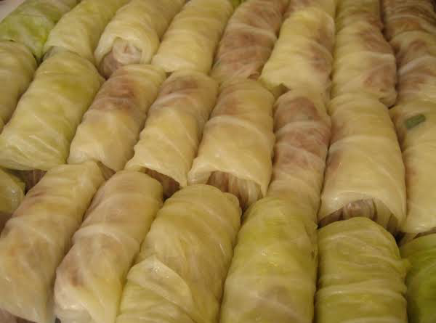
Holupki Sale
Available in pre-packaged quantities:
3 Holupki @ $7.50
6 Holupki @ $15.00

All Dinners/Holupki must be Pre-ordered
To place an order please call:
570-822-6028
or
570-931-1894

